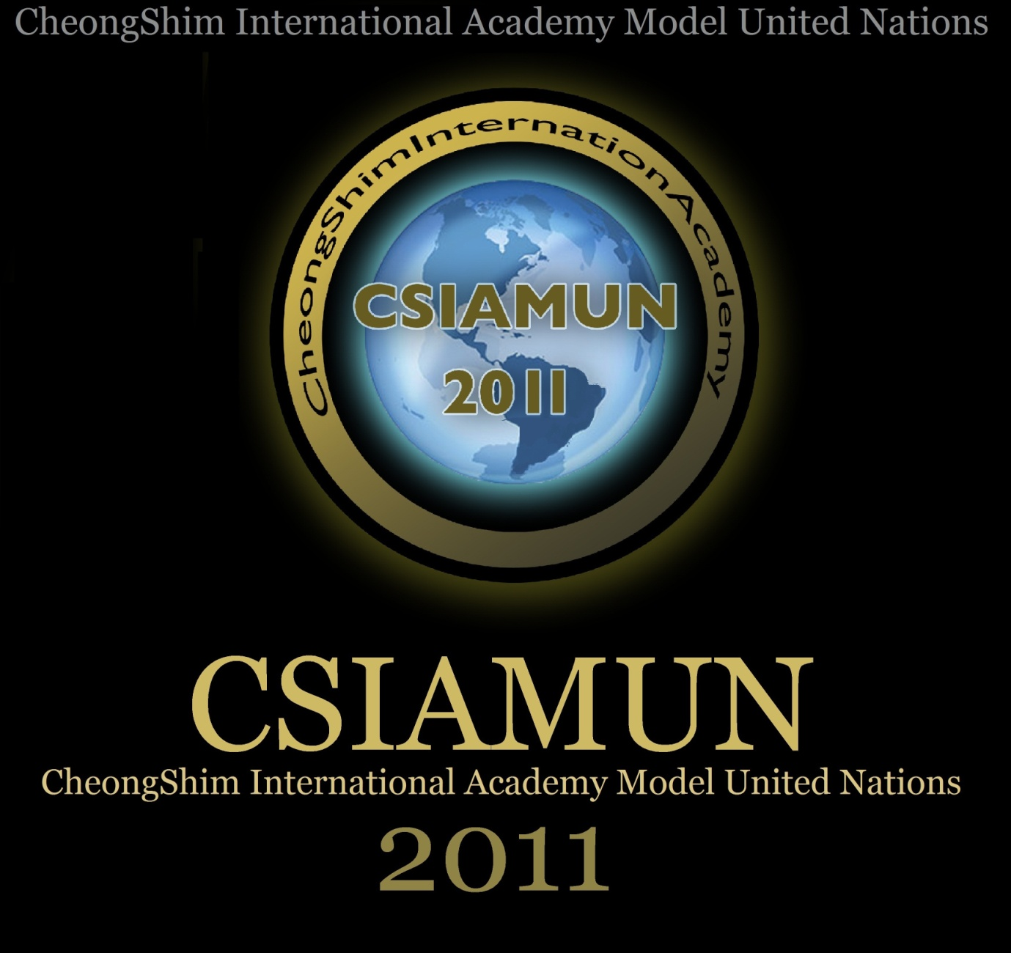

Date: February 12th ~ 13th

Venue: CheongShim International Academy

Greetings from the Secretary General:

It is our distinct honor and privilege to formally invite you to the 3rd annual session of CSIA Model United Nations. The session will be held February 12th-13th, 2011 at the Cheongshim International Academy in South Korea, Gapyeong. CSIA Model United Nations was founded in 2008 on the principles of political participation, diplomacy, and global awareness. CSIAMUN pursues a tradition of high quality debate, diversity, and altruism in pursuit of peace. It is our hope that the 3rd session will become the stepping stone for many more conferences to come. Each year we plan to make the next conference more international & broader in its scope, becoming a stage for students to have a truly great learning experience and leave with a myriad of cherished memories. As we continue into CSIAMUN’s 3rd year of existence, we invite you to join us for an exciting two days of adventure. This year’s theme is “Reconciliation, Rights & Renewal”. We will be looking forward to the collaboration and new friendships formed among students that will further our bonds and help to bring about global harmony more substantially.

-Che Yeon Hyun

Table of Contents

Schedule

Agendas

Rules of Procedure

Word List for Resolutions

Sample Resolution

CSIAMUN SCHEDULE
First day (Feb, 12th)
8:00: Student Officer Briefing
9:00: Registration (arrival of delegates)
9:00~10:00: Briefing, chair introduction, opening the conference
10:00~12:00: Opening speeches in each committee
12:00~1:00: Lunch time
1:00~6:00(maximum): Lobbying, approving resolutions
6:00 Dinner
7:30 Entertainment (from participants please!)
Second day (Feb, 13th)
8:00: Student Officer Briefing
9:00: Second Day session begins
9:00~12:00: Debate
12:00~1:00: Lunch time
1:00~3:30 (approximately, depends on the number of resolutions): Debate
3:30~4:30: Plenary session
4:30~5:30: Announcing Superlatives, Speeches by Student Officers, Closing Ceremony
6:00 Closing Dinner

Third Day (Feb. 14th )

8:00: Breakfast

8:45 Departures of foreign students to airport / or hotel
Beginning of “Korean Adventure Challenge”
(Feb 14th – 19th)

Agenda for CSIA MUN Feb 12-13, 2011
“Reconciliation, Rights, and Renewal”
HRC
1. Eradicating the discrimination against women, in law and practice.
2. Issue of human rights obligations related to access to safe drinking water and sanitation.

Inter-Religious committee
1. Prohibition and restrictions of defaming religions by law
2. UN's rights to intervene countries with religions that excessively restrict women's rights

ECOSOC
1. International cooperation for sustainable development in developing countries.
2. Plans to promote efficacy of UN budget.

GA
1. Defining resource nationalism and the need to increase international cognitions.
2. Creating a fundamental overhaul of energy policies within members of the UN

Environment
1. Reduction of the world's reliance on fossil fuels with respect to sustainable development.
2. Renewing measures towards stabilization of greenhouse gas concentrations in the atmosphere

CSIAMUN Rules of Procedure – Concise version

Quorum
You need at least 1/2 members

Duties of each delegate
- Speakers need to address each other in the Third Person at all times.

- Delegates should stand when speaking and should not sit down until after the speaker has finished answering the delegate’s question.

- Delegates must avoid the use of insulting or abusive language.

- Delegates must yield the floor when required to do so by the Chair

- Delegates should address the chair and the house before presenting their speech [Example: “ Dear Chair, fellow delegates,…”]

Rising to Points:
Points during debate may NOT interrupt a speaker except for a Point of Personal Privilege, which refers to audibility.

1. Point of Personal Privilege:
  - Refers to the comfort and well-being of the delegate
  - May only interrupt a speaker if it refers to audibility
  - Example: “Could the windows please be opened? It is very hot in here.”

2. Point of Order:
  - Refers to procedural matters only, i.e. if the chair makes an error in the order of debate or in the setting/observing of debate time
  - May NOT interrupt a speaker
  - Can only refer to something that just happened
  - Example: “Is it in order for the delegate to yield the floor to another delegation since the floor was previously yielded to him by Saudi Arabia?”

3. Point of Information to the Speaker:
  - A question directed to the delegate having the floor, and who has indicated that he/she is willing to yield to points of information
  - Speaker asking the Point of Information may only speak if recognized by Chair
  - Must be formulated in the form of a question, Follow—ups are for the rule of thumb, NOT ALLOWED. May make exceptions in SC and maybe ECOSOC.
  - Example: “Could the honorable delegate, as she is the main submitter of this resolution, please explain to the house what she intends with clause 3?”
  - As a rule of the thumb, accept 6 for the first two speakers, than 2 or 1 for the rest(maybe 3 for an amendment)

4. Point of Information to the Chair/Rapporteur:
  - A question to the chair/rapporteur
  - May NOT interrupt a speaker
  - Can refer to almost anything, from issues(Rapp) to personal priorities(chair)
  - Chair to answer clearly and swiftly and move on with business
  - Example: “At what time do we adjourn for lunch?”(Chair), “Is western Sahara a sovereign state?”(Rapporteur)

5. Point of Parliamentary Enquiry:
  - Point of information to the chair concerning Rules of Procedures
  - May NOT interrupt a speaker
  - Example: “Could the Chair please explain to the house what is meant by closed debate?”

Motions:

1. “Moving the previous question” (“Motion to move directly into voting procedures”)
  - Calls for the closure of debate and a vote to be taken on the motion (resolution/amendment) pending
  - May be moved by the Chair or a delegate, may not interrupt a speaker
  - Also known as: “Moving the Previous Question”
  - Requires a “second” by the house, and is quickly voted on if any objections
  - May be overruled by Chair if time needs to be filled

2. “Motion to go into time against/in favour”
  - debate in time in favor/against is not very productive
  - needs a second
  - can be ruled out of order by the chair

3. “Motion to extend debate time”
  - calls for more debate time on the resolution / amendment
  - needs a second
  - can be ruled out of order by the chair (due to lack of time, guest speaker,…)
There ARE other motions, but you can mostly ignore them

Yielding the floor to other delegations
- The floor may be yielded by one delegation to another only ONCE consecutively

- Where delegations consist of more than one member, delegates from the same delegation may not yield the floor to each other (ECOSOC, SC!!)

Amendments to the First Degree
- Amendments can only be submitted by a speaker who has the floor

- An amendment is only in order if it is submitted to the Chair on the official Amendment Sheet before the delegate takes the floor, and must be easily legible

- Amendments will only be entertained if the speaker on the floor moves the amendment.

- The Chair reads it out for all delegates to note down.(We usually have equipments)

- EVERY amendment will always be debated, and put to a vote! (But maybe without debate)

- Closed debate for amendments

- Only ONE amendment (max: one entire clause) per amendment sheet will be in order

- Chair should prioritize constructive amendments, e.g. add a clause.

- If an amendment fails, the speaker who proposed the amendment does not automatically retain the floor. –let s go over this
- On an amendment, delegations can only vote for, against or abstain. NGOs may not vote.

- The Chair should keep all passed amendments together, this is important for updating the resolution when it passes!

Amendment to the Second Degree
- Same procedure as for normal amendment

- Amendment to the second degree can be entertained only during the time against the first degree amendment. .

- Example: Amendment: to insert: “Endorses the work of organization A”. Amendment to the Amendment: “Endorses the work of organization B”. If the amendment to the amendment passes, debate on the original amendment is not resumed. Passing the amendment to the amendment, after all, means the forum prefers B above A. If the forum desires a combination of A and B, it should fail the amendment to the amendment, and submit a new amendment to the amendment which proposes: “Endorses the work of organizations A and B”.

- Debate on the original amendment can be resumed after an amendment to the amendment passes that refers to one element in the original amendment only

- Example: Amendment: to insert the clause: “Calls upon organization A to support faction X”. Amendment to the Amendment: “Calls upon organization B to support faction X”. If the forum passes this amendment to the amendment, it may still prefer to continue discussing whether to support faction X at all.

- An amendment to the third degree or higher is out of order.

- Chair needs to explain clearly the consequence of the vote on the amendment to the amendment, as it always confuses many delegates. Take your time to do it!

Voting
- Only member states of the UN may vote. No non-member delegation (NGO, UNO, OO) is allowed to vote, NOT EVEN ON AMENDMENTS!

- Delegations voting on a resolution or an amendment may vote in favor or, against.

- During voting procedures, all points are out of order.

- A resolution will pass if the number for exceeds the number against regardless of the number of abstentions
- A resolution or an amendment with a tied vote fails.

Debate time and Debate mode
- The Chair will propose the limitation of debate time before the start of debate.

- Extension of debate time is allowed only in exceptional circumstances and only if time-frame permits.

- Chair decides on limitation of speaking time by individual speakers (Usually the maximum is 3 minutes, then 1 min toward end of debates),

- The whole time will be different for committee to committee

Note-passing
- Note-passing is allowed, although no personal messages no non-English notes

- Chair may suspend note-passing if it gets too noisy in the house.

- Note-passing is suspended during voting.

Funding

- Funding may be discussed and included in CSIAMUN resolutions

- Keep clauses or statements referring to funding very broad, no specific numbers or funds i.e. in order: “Asks the IMF to fund above mentioned proposal”, not in order: “Asks the IMF to sponsor $ 3,545,623 million out of their developing nations fund”

Miscellaneous

- A male delegate should always wear a blazer and a tie, delegates MUST wear blazers when taking the floor or asking points of information.

- Say: “We will meet again at 12.30”; Never say: “We will adjourn for 30 min”. Always calculate about 5-10 min in addition for the delegates to get seated and settled and ready.

Original Copyright to the THIMUN Foundation

Edited by Young Chan Cho of CSIAMUN

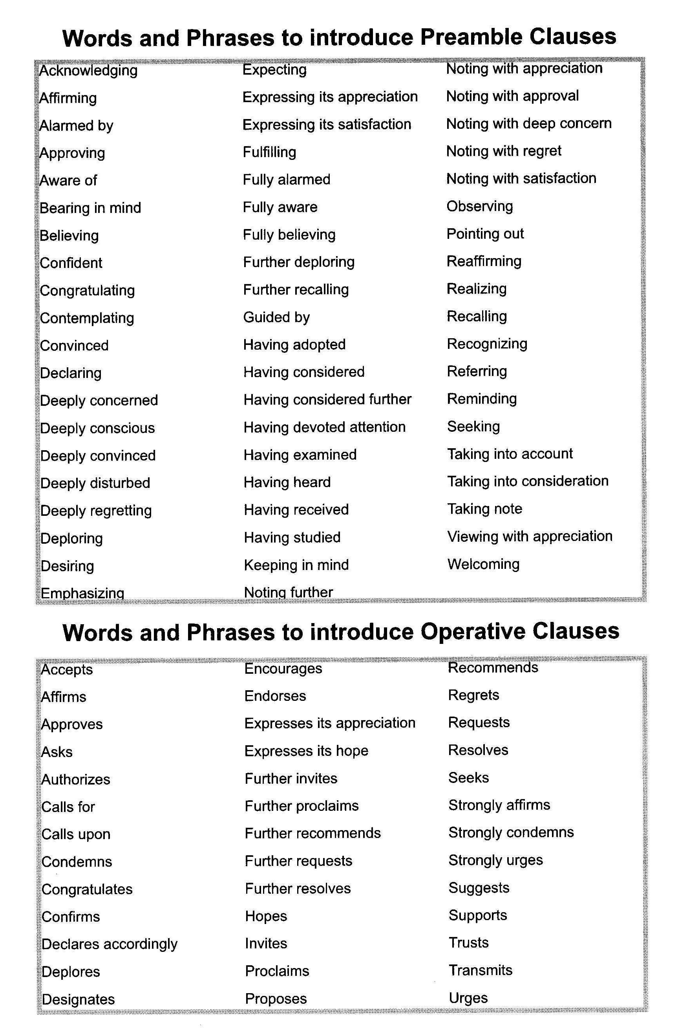
Word List for Resolutions

Sample Resolution

Forum: General Assembly 1st Committee (Disarmament and International Security)

Question of: Consolidation of peace through practical disarmament measures

Main submitter: Jordan

THE GENERAL ASSEMBLY,

Defining the term “practical disarmament” as the reduction and possible elimination of the use, trade, and development of Small Arms and Light Weapons (SALW),

Defining “unnecessary” as anything beyond the level of individual and national protection,

Noting with deep concern that illicit SALW continues to be an issue in many developing countries, especially in various African nations,

Alarmed by the statistics that show a substantial percentage of money of various developing nations is spent on developing weaponry, instead of their people,

Recalling the most recent GA meeting session in which an overwhelming 153 votes were for the establishment of an Arms Trade Treaty, with 28 states abstaining and only one vote against this proposal,

Noting also that many implementations of various laws and treaties are not followed through by consenting states and even if acted on, are often executed in a poor fashion,

Viewing with appreciation that various member states have chosen to represent themselves in the Group of Interested States in practical disarmament measures (GIS), who have provided financial assistance to many countries in the process of executing various projects involving practical disarmament,

Bearing in mind that disarmament of SALW will take time and that certain states may be economically dependent on the trade of weapons,

Congratulating the members for the establishment of the Group of Governmental Experts to consider further steps to enhance international cooperation in preventing, combating and eradicating illicit brokering in small arms and light weapons on December 8th, 2005, and at the success of the most recent meeting in New York,

Also congratulating the Group of Governmental Experts in the newly adopted consensus report, which gives a description of what constitutes as illicit brokering in small arms, providing guidelines for international cooperation and raises the importance of the issue at future GA meetings,

- Recommends that all member states initiate multilateral and bilateral negotiations involving the importing and exporting of SALW which may involve the following steps:
- submission of requests from individual involved states,
- negotiation of conflicting requests, if unresolved to be taken to the International Court of Justice (ICJ),
- implementation of such guidelines within one year of agreement, such as but not limited to:
    - education of associated officials on alterations of procedure,
    - public announcements in said states to inform citizens of changes,
    - maintenance of said changes by all involved states;

- Expresses its full support for the establishment of an Arms Trade Treaty, the content of which includes but is not limited to:
  - prohibiting all countries in the General Assembly (GA) from importing or exporting SALW if there is evidence that shows profit from the trade will violate international law or hinder the development of individual nations and/or international development,
  - prohibiting the sale of SALW to any individual who may use them in an unlawful manner,
  - supporting the necessity of an ID card with all appropriate information when purchasing or reselling SALW,
  - requesting the GA to reevaluate various SALW which are currently classified as legal for civilian use;

- Calls for all individual states to strengthen national legislation on the topic of SALW by implementing laws such as but not limited to:
  - limiting the variety of weapons available,
  - limiting the number of weapons an individual may possess,
  - restricting the amount of ammunition for such weapons that an individual may possess,
  - continuing the supervision of all civilian weaponry use, trade and development;

- Calls on all member nations in post-conflict regions to, with the consent of the host country and assistance from various international disarmament organizations such as Group of Interested States (GIS), actively participate in the disarmament of the world in ways such as but not limited to:
  - restriction of trade and collection of small arms and light weapons by:
    - requesting that national governments and the International Criminal Police Organization (INTERPOL) to prevent the illicit trading of small arms by:
      - actively seeking and destroying black markets in which illegal trade of arms is abundant by increasing the security level,
      - reemphasizing the fact that those charged for illicit trading of small arms will receive severe punishment after undergoing a trail in the appropriate court, domestic or international,
    - requesting national governments to collect all unnecessary, unauthorized arms by:
      - enacting an arms-registration program in which an individual must register with the government in order to bear arms,
      - creating an amnesty period in which all arms bearers must register their arms possession with the government,
      - declaring that any unregistered bearing of arms after the amnesty period may result in prosecution in court,
      - providing a sense of security to ex-arm bearers of post-conflict regions with the help of national police and the International Police Criminal Organization (INTERPOL)
    - strengthening border controls by :
      - Dispatching inspectors, appointed by the respective government, to monitor embargoes going in and out of the country,
      - Also dispatching government designated border controls, who may carry weapons with minimal capacity(decided on by the government) to deal with emergencies, such as rebellions causing violence against the border patrols;

  - discovery and destruction of existing landmines by:
    - requesting all states in conflict or post-conflict states to keep an active record of:
      - landmines and minefields by maps, diagrams or other records to indicate the location of the mines and previous battlefields known to have been planted landmines,
      - the complete information on the type, type of use, lifetime and the date and time of laying for the purpose of the detection and clearance of the mines after the time of usage,
    - calling for a strategic program that will eliminate and destroy existing landmines and minefields from previous battlefields that do not comply with the Certain Conventional Weapons (CCW) Amended Protocol II requirements by:
      - continuous inspection of mine-building factories,
      - detection of land mines with specially trained canine units and/or metal detectors provided by the United Nations Office for Project Services (UNOPS),
      - destruction of potentially dangerous landmines that do not comply with the Certain Conventional Weapons (CCW) by trained mine elimination professionals supported by the International Campaign to Ban Landmines (ICBL),
  - demobilization of unnecessary forces and the reintegration of former combatants within post-conflict nations funded by the Multi-Donor Trust Fund(MDTF) and with the assistance of the Multi-Country Demobilization and Reintegration Program (MCDR) by:
    - creating an amnesty period for existing unnecessary military groups to restore their weaponry to their national government and disband,
    - providing transitional allowance and basic supplies such as food, clothing, and housing that are necessary for reintegration, to those who comply with the previous sub-sub clause,
    - launching of projects that will assist ex-combatants economically and socially such as but not limited to:
      - formal education,
      - employment generation,
      - job training,
      - counseling;

- Suggests the elaboration and update of the 3P Project (Peace-making, Peace-building, and Peace-keeping) as introduced in General Assembly Resolution 51/45N of 1996 to include all post-conflict areas where consolidation of peace is immediate necessity with the financial assistance provided by the national governments of the member states and various Non-Governmental Organizations (NGOs) such as but not limited to the Group of Interested States (GIS), the International Monetary Fund (IMF), and the United Nations Development Programme (UNDP) by:
  - the creation of a sense of peace within regions currently involved in conflict by:
    - UN efforts to resolve existing international and domestic conflicts by organizing peace talks,
    - implementation of practical disarmament following the guidelines listed in operative clause 4,
  - re-construction of necessary infrastructure, stimulation of the economy, and construction of social welfare systems for the provision of humanitarian aid which includes but not limited to:
- insurance policies that will assist people’s lives,
- re-organization of the education system for the children,
- assistance for the lives of orphans, single mothers, and the war disabled,
- construction of refugee camps with the assistance of Habitat for Humanity that will provide housing to the homeless population created by violent conflicts,
- family-finding projects which will allow people to reunite with their family members from whom they have been separated due to long lasting violent conflicts;

- Hopes that all member states will support the content of the resolution and remain actively focused on the matter.

